HORMISDALLEN SCHOOL – KYEBANDO

Lesson notes for middle class numbers.

Term I - 2020

Week I

Period 1-5

Orientation

* Welcoming the learners
* Taking the learners around the school
* Showing the learners important places i.e. toilets, offices, kitche etc.

Week 2

Period 1-5

Content

Number from 0-20

0 1 2 3 4 5 6 7 8 10

11 12 13 14 15 16 17 18 19 20

Activities:

* Reciting the numbers
* Identifying the numbers
* Recognizing the numbers
* Counting the numbers
* Writing the numbers
* matching the numbers
* Sorting the numbers

Week 3

Period 1

Content

matching the same numbers

0 3

1 4

3 0

4 1

5 2

Activities

* Reciting the numbers
* Identifying the numbers
* Recognizing the numbers
* Sorting the numbers
* Reading the numbers
* Matching the numbers

Period 2

Content

Matching same numbers

6 8

7 9

8 10

9 6

10 7

Activities

* Reciting the numbers
* matching the numbers
* Reciting the numbers
* Writing the numbers
* Identifying the numbers

Period 3

Content

Matching the numbers and writing

11 13 ________

12` 14 _________

13 11 ________

14 12 ________

15 15 _________

Activities

* Reciting the numbers
* Sorting the numbers
* Singing the number songs
* Writing the numbers
* Identifying the numbers
* Recognizing the numbers
* Matching the numbers.

Period 4

Content

Matching the numbers and writing

16 18 ____

17 19 _____

18 20 _____

19 16 _____

20 17 _____

Period 5

Content

Writing the numbers correctly.

= =

=

Activities

* Singing a number song
* Reciting the numbers rhymes
* Identifying the numbers
* Recognizing the numbers.,
* Writing the numbers correctly
* Reading the numbers
* Naming the numbers

Week 4

Period 1

Content

Writing the numbers correctly.

µ = ω =

8 =

___

0 = p

Activities

* Singing the numbers songs
* Reciting number rhyme
* Identifying the numbers
* Recognizing the numbers
* Reading the numbers
* Writing the numbers correctly

Period 2

Content

Ring the correct number

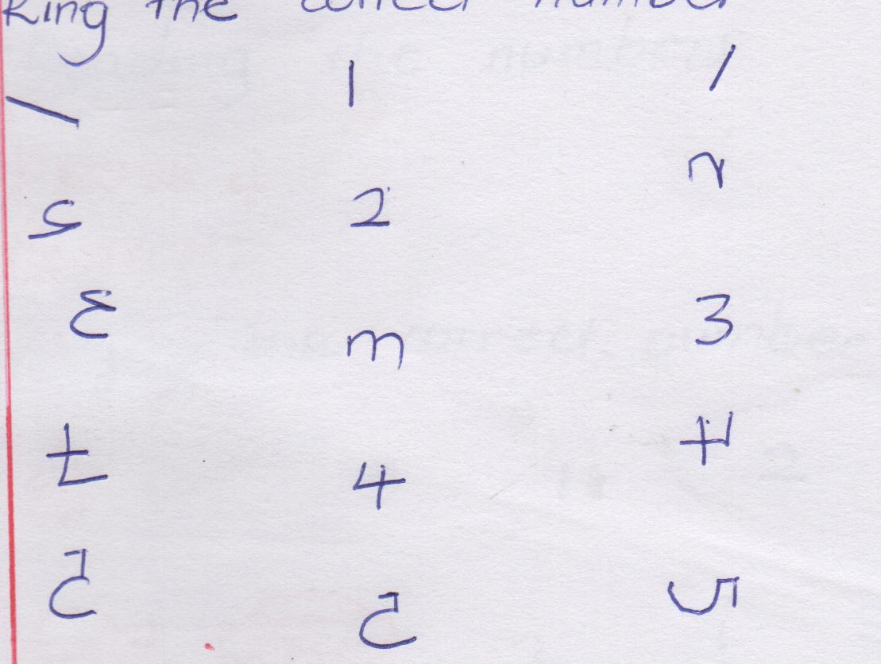

Activities:

* Singing the number songs
* Reciting number rhymes
* Reading the numbers
* Writing the numbers
* Ringing the correct numbers
* Identifying the numbers
* Recognizing the numbers
* Sorting the correct numbers.

Period 3

Content

Ringing the correct numbers.

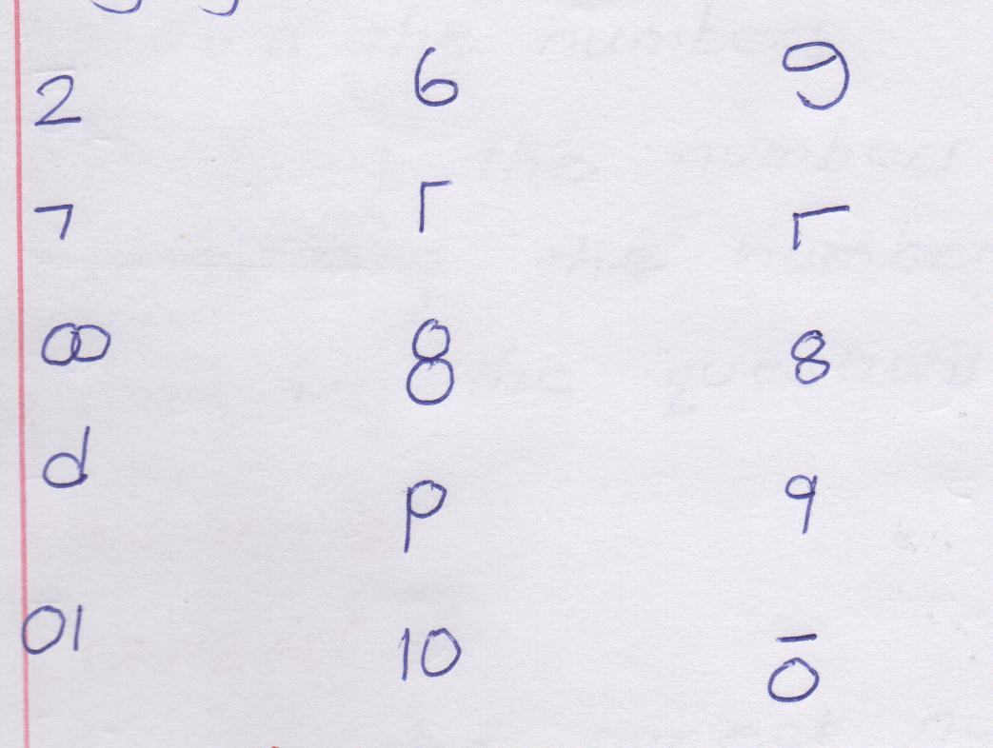

Activities

* Singing number songs
* Reciting number rhyme
* Ringing the correct numbers
* Writing the numbers
* Reading the numbers

Period 4

Content

Ringing the correct numbers.

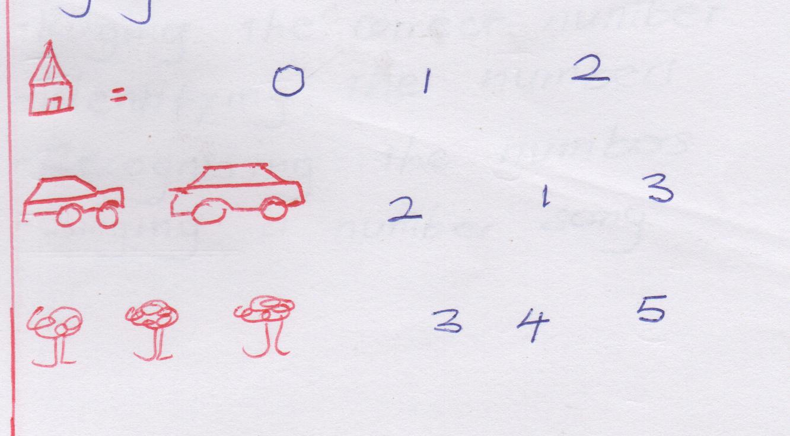

Activities

* Reciting a number rhyme
* Drawing the picture
* Counting the pictures
* Ringing the correct number
* Writing the numbers
* Reading the numbers
* Identifying the numbers
* Recognizing the numbers
* Answering the questions.

Period 5

Content

Ring the correct number.

 5 6 7



11 10 9

9 8 10

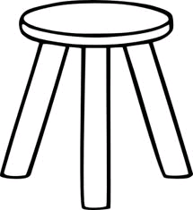

Activities

* Reciting the numbers
* Drawing the pictures
* Naming the pictures
* Answering the questions
* Ringing the correct numbers
* Identifying the numbers
* Recognizing the numbers
* Singing a number song.

Week 5

Period

Content

Counting and matching

Activities

* Reciting number rhymes
* Singing a song
* Drawing the pictures
* Counting the pictures
* Matching accordingly.

Period 2

Content

Counting and matching

6

4



 5

Activities:

* Drawing the pictures
* Counting the pictures
* Writing the numbers
* Reading the numbers
* matching the pictures to numbers
* Identifying the numbers
* Recognizing the numbers

Period 3

Content

Reading and drawing

4 = 0 0 0 0

1 =

3 =

2 =

Activities

* Identifying the numbers
* Recognizing the numbers
* Writing the numbers
* Drawing the pictures according to the given numbers.
* Counting the pictures

Period 4

Content

Reading and drawing.

5 =

6 =

7 =

Activities

* Identifying the numbers
* Recognizing the numbers
* Reading the numbers
* Writing the numbers
* Drawing the pictures
* Naming the numbers

Period 5

Content

Reading and drawing

7 = 3 =

4 = 1 =

Activities

* Drawing the pictures
* Writing the numbers
* Reading the numbers
* Naming the numbers
* Identifying the numbers
* Recognizing the numbers.

Week 6

Period 1

Content:

Reading and drawing

6 =

8 = 5 =

Activities

* Reciting the number rhyme
* Sorting the numbers
* Counting the pictures
* Drawing the pictures
* Recognizing the numbers.
* Identifying the numbers.
* Writing the numbers.

Period 4

Content:

Counting the blocks and writing the numbers.

= 1

=2

=2

= 3

Activities

* Reciting a number rhyme
* Sorting the numbers
* Drawing the blocks
* Counting the blocks
* Writing the numbers
* Recognizing the numbers
* Identifying the numbers.

Period 5

Content

Counting the blocks and writing the numbers.

Activities

* Identifying the numbers.
* Recognizing the numbers
* Reading the numbers
* Naming the numbers
* Writing the numbers
* Drawing the pictures accordingly.
* Singing a number song
* Reciting number rhyme.

Period 2

Content

Counting and writing:

= 2

0 0 0 0 =

=

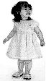

=

Activities

* Drawing the pictures
* Counting the pictures
* Writing the numbers
* Answering the questions
* Identifying the numbers.

Period 3

Content

Counting and writing



 =





=

=

Activities

* Reciting the number rhyme
* Sorting the numbers
* Drawing the blocks
* Counting the blocks
* Writing the numbers
* Reading the numbers
* Naming the numbers
* Recognizing the numbers
* Identifying the numbers.

Week 7

Period 1

Content

Joining of the dotes

0 1

2 3

Activities

* Writing the numbers
* Drawing the dots
* Joining the dots
* Reading the numbers
* Identifying the numbers.

Period 2

Content

Joining the dots.

5 7

4 6

Activities

* Identifying the numbers
* Recognizing the numbers
* Drawing the dots
* Writing the numbers
* Joining the dots
* Reciting the numbers.

Period 3

Content

Filling in the missing numbers

0 1 ___ 3 __ 5

6 ___ 8 ___ 10

Activities

* Identifying the numbers.
* Recognizing the numbers
* Writing the numbers
* Filling in the missing numbers
* Reading the numbers
* Naming the numbers
* Sorting the numbers.

Period 4

Content

Filling in the missing numbers.

10 __ 12 __ 14

15 __ __ 18 20

Activities

* Reciting the number rhyme
* Sorting the numbers
* Counting the numbers
* Writing the numbers
* Filling in the missing numbers
* Identifying the numbers
* Recognizing the numbers

Period 5

Content

Matching the same shapes.

Activities

* Reciting the number rhyme
* Sorting the numbers
* Counting the numbers
* Writing the numbers
* Filling in the missing numbers
* Identifying the numbers
* Recognizing the numbers

Period 5

Content

Matching the same shapes.

Activities:

* Identifying the shapes
* Recognizing the shapes
* Naming the given shapes
* Drawing the shapes
* Matching the same shapes.

Week 8

Period 1

Content

Matching the same shapes.

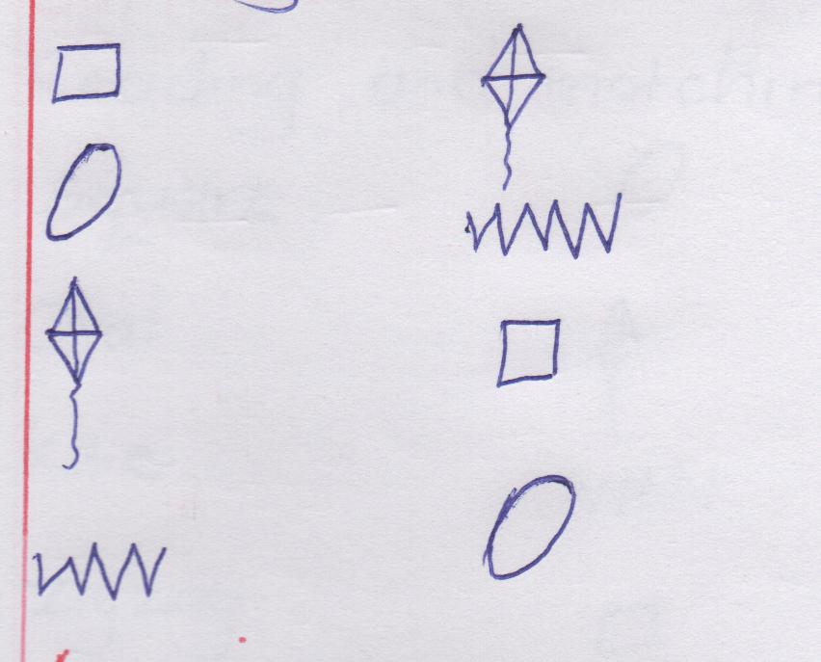

Activities

* Identifying the shapes
* Recognizing the different shapes
* Drawing the shapes
* Naming the shapes
* Matching the shapes.
* Sorting the shapes

Period 2

Content

Reading and matching

Star

Triangle

Circle

Rectangle

Activities

* Identifying the shapes
* Recognizing the shapes
* Drawing the shapes
* Naming the shapes
* Reading the names.
* Matching the shapes
* Sorting the shapes.

Period 4

Content

Reading and drawing the shapes.

* Star
* Triangle
* Circle
* Rectangle

Activities

* Identifying the shapes
* Recognizing the shapes
* Reading the names
* Drawing the shapes
* Writing the names
* Answering the questions.

Period 5

Content

Reading and matching

oval square

triangle star

square oval

star triangle

Activities

* Identifying the names
* Recognizing the names
* Writing the names
* Spelling the names
* Reading the names
* Matching accordingly.

LESSON NOTES FOR MIDDLE CLASS TERM II, 2020

BASIC NUMERACY

WEEK 1

PERIOD 1

Content: Days of the week.

* Sunday
* Monday
* Tuesday
* Wednesday
* Thursday
* Friday
* Saturday

Activities

* Reciting a rhyme about numbers.
* Reciting days of the week.
* Singing a song.
* Reciting days of the week.
* Spelling days of the week.
* Answering the question orally.

Period 2

Content: Days of the week.

Wednesday, Thursday, Friday, Saturday

Activities:

* Reciting a rhyme about days of the week.
* Singing a song.
* Reciting and spelling of the week.
* Answering the questions.

period 3

Content: Months of the year.

* January
* February
* March
* April
* Reciting or rhyme
* Reading months of the year
* Spelling months of the year
* Writing months of the year.
* Answering the questions orally
* Counting months of the year.

Period 4 : Content Months of year.

May, June, July, August

Activities.

* Reciting a rhyme
* Reading and spelling months of the year.
* Writing months of the year.
* Answering the questions orally.
* Counting months of the year.

Period 5

Content: Months of the year.

September, October, November, December

activities

* Reciting a rhyme
* Reading months of the year.
* Spelling months of the year
* Writing months of the year
* Singing a song
* Answering the questions
* Counting months of the year

Week 2

Period 1

Content: Important days.

* Easter
* Sunday
* Good Friday
* Idi day
* Christmas

Activities

* Singing a song
* Reciting a rhyme
* Mentioning the given important days
* Answering the questions orally

Period 2

Content:

* Identifying and differeciating numbers between the big and the small

I 3

2 3

2

Activities

* Recognizing the numbers
* Identifying the numbers.
* Reading the numbers.
* Naming the numbers
* counting the numbers
* Ringing the small numbers.

Period 3

Content;

Ringing the small numbers.

3 5 1 2 7

Activities

* Recognizing the numbers.
* Identifying the numbers.
* Reading the numbers
* Naming the numbers
* Ringing the small numbers.
* Counting the numbers.
* Answering the questions.

Period 4

Content

Ringing the small number.

5 3 8 10 7

Ring the small picture

Activities

* Recognizing the numbers.
* Identifying the numbers.
* Reading the numbers.
* Naming the numbers
* Ringing the small numbers.
* Counting the numbers
* Answering the questions,.

Period 5

Content:

Ring the big numbers.

1 2 2 3 3

Activities

* Identifying the numbers.
* Recognizing the numbers
* Reading the numbers
* Ringing the big numbers
* Writing the numbers
* Answering the questions.

Week 3

period 1

Content:

Ringing the big numbers.

5 3 2 9 1 6

Activities

* Identifying the numbers
* Recognizing the numbers.
* Reading the numbers
* Ringing the numbers
* Writing the numbers.

Period 2

Content

Ringing the big numbers Ring the big pictures

5 8 9 2 7 3

Activities

* Identifying the numbers
* Recognizing the numbers
* Writing the numbers
* Reading the numbers
* Ringing the big numbers
* Counting the numbers

Period 3

Content: counting and writing numbers on the abacus.

Activities

* Drawing the abacus
* Drawing the beads
* Counting the beads
* Writing the numbers
* Answering the questions.

Period 4 : Content

Counting and writing on the abacus

Activities

* Drawing the abacus
* Drawing the beads
* Counting the beads
* writing the numbers

Period 5

Content

Counting and writing on the abacus.

Activities

* Drawing the abacus
* Drawing the beads
* Counting the beads
* Writing the numbers.

Week 4

Period 1

Content

Abacus reading and drawing.

2

Activities

* Drawing the abacus correctly.
* Identifying the numbers
* Reading the numbers
* Writing the numbers correctly.

Period 2

Content: Reading and drawing beads on the abacus.

0 2 3

Activities

* Drawing the abacus correctly.
* Drawing the beads according to the given numbers.
* Reading the numbers.
* Identifying and recognizing the numbers.

Period 3

Content: Find the numbers which comes between i.e.

0 __ 2 2 --- 3 --- 5

Activities

* Identifying the numbers
* Recognizing the numbers.
* Reading the numbers
* Answering the questions

Period 4

Content: Find the numbers which comes between.

1 -- 3 ---- 6 5 ----7

Activities

* Identifying the numbers
* Recognizing the numbers
* Writing the numbers
* Naming the numbers

Period 3

Content: Find the numbers which comes between

6 -- 8 7 --- 9 8 --- 10

Activities

* Identifying and recognizing the numbers.
* Writing the numbers which comes between
* Reading the numbers.

Period 4

Content: Finding the number which comes after.

1 ___ 2 2 ---- 3 ----

Activities

* Identifying the numbers.
* Recognizing the numbers
* Reading the numbers
* naming the numbers
* Writing the number which comes after.

Period 3

Content: Finding the numbers which comes after

4 --- 5 ---- 6 --- 7 ----

activities

* Identifying the numbers
* Recognizing the numbers
* naming the numbers
* reading the numbers

Period 3

Content: find the numbers which comes after.

8 ---- 9 ---- 10 ---- 11 -----

Activities

* Identifying and recognizing the numbers.
* Naming the numbers
* Reading and writing numbers which comes after.

Period 4

Content

Finding the number which comes before.

--- 2 ---3 ----4 ---- 5

Activities

* Identifying the numbers
* recognizing the numbers
* naming and writing the numbers which comes befor.
* Reading the numbers.

Period 5

content:

Finding the numbers which comes before.

--- 6 --- 7 ---- 8 --- 9

Activities

* Identifying the numbers
* Recognizing the numbers
* Naming the numbers
* Reading the numbers
* Answering the questions
* Writing the numbers

Week 6

period 1

Content:

Number names

o – zero

1 – one

2 - two

3 – three

Activities

* Identifying the numbers and their names.
* Recognizing the numbers and their names.
* Naming the numbers
* Reading the numbers names.

Period 2

Content

Number names

3 - three. 4 – four 5 – five 6 - six

Activities

* Identifying the number and their names.
* Recognizing the number and their names
* Reading the number names
* Writing the number names
* Spelling the given number names.

Period 3

Content:

Number names

7 - seven

8 – eight

9 – nine

10 – ten

Activities

* Identifying the number and their names
* Recognizing the number names
* Naming the numbers
* Spelling the number names

Period 4

Content: reading and matching

zero 3

one 2

two 1

three 0

Activities

* Writing the numbers and the names.
* Reading the name and matching to their numbers.
* Spelling the given number names.

Period 5

Content: Reading and writing

four - 4 six - ___ seven - ____

five - ____ eight - 8 nine - _____

ten - _____

Activities

* Identifying the numbers and their names.
* Recognizing the numbers and their names.
* Writing the numbers and their names.
* Reading the number names
* Writing number according to their given names.

Week 7

Period 1

Shapes

Oval - triangle

star - rectangle

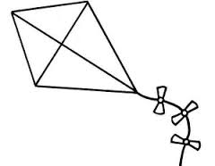

circle - kite

Activities

* Identifying and recognizing the shapes.
* Drawing the shapes
* Naming the shapes
* Writing their names.

Period 2

Content

Shapes



Rectangle Kite

Square zig-zag

Activities

* Naming the shapes.
* Drawing the shapes.
* Spelling the names
* Matching accordingly

Activities

* Identifying and recognizing the numbers.
* Adding the numbers.
* Answering the questions
* Writing the numbers.

Period 4 & 5

Content:

Adding the number horizontally.

4 + 2 = ___ 5 + 3 = ___

5 + 4 = ___ 3 + 1 = ____

1 + 2 = ___ 2 + 2 = ____

Activities

* Identifying the number
* Recognizing the numbers
* Writing the numbers
* Writing the numbers
* Answering the questions

Week 8

Period 1

Content.

Adding the number vertically.

1 2 2

+ 1 + 2 + 2

Activities

* Identifying the numbers
* Recognizing the numbers
* Adding the numbers
* Writing the numbers
* Answering the questions.

Period 2

Content

Adding the numbers

3 3 4

+ 2 + 3 + 2

Activities

* Identifying the numbers.
* Recognizing the numbers.
* Adding the numbers.
* Answering the question.
* Writing the numbers.

Period 3

Content.

Adding the numbers in circles

i.e.

Activities

* Identifying and recognizing the numbers.
* Reading the numbers.
* Adding the numbers.
* Drawing good circle.

Period 4

Content

Adding the numbers in the circle.

2 + 1 =

2 + 2 =

Activities

* Drawing the circle
* Identifying the numbers
* Answering the questions
* Adding the numbers
* Identifying the circle.

Period 5

Content:

Adding the numbers in the circle.

3 + 1 = __

3 + 3 = __

Activities

* Identifying and recognizing the numbers
* Drawing good circles.
* Writing the numbers
* Adding the numbers

Week 9

Period 1

Subtraction of pictures.

Activities

* Identifying the pictures
* Recognizing the pictures
* Drawing the pictures
* Subtracting the pictures
* Answering the questions.

Period 2

Content: Subtracting the pictures.

 - = ______



- = _____

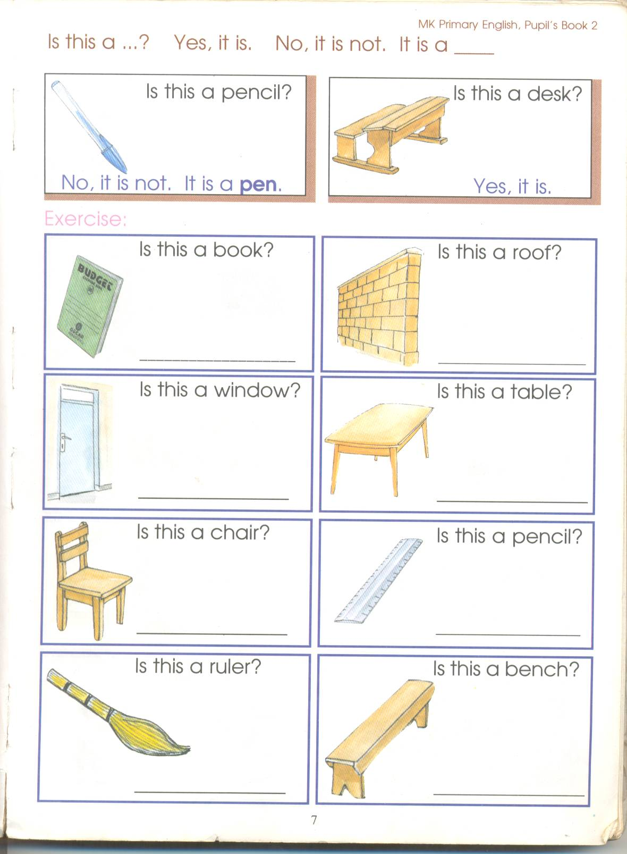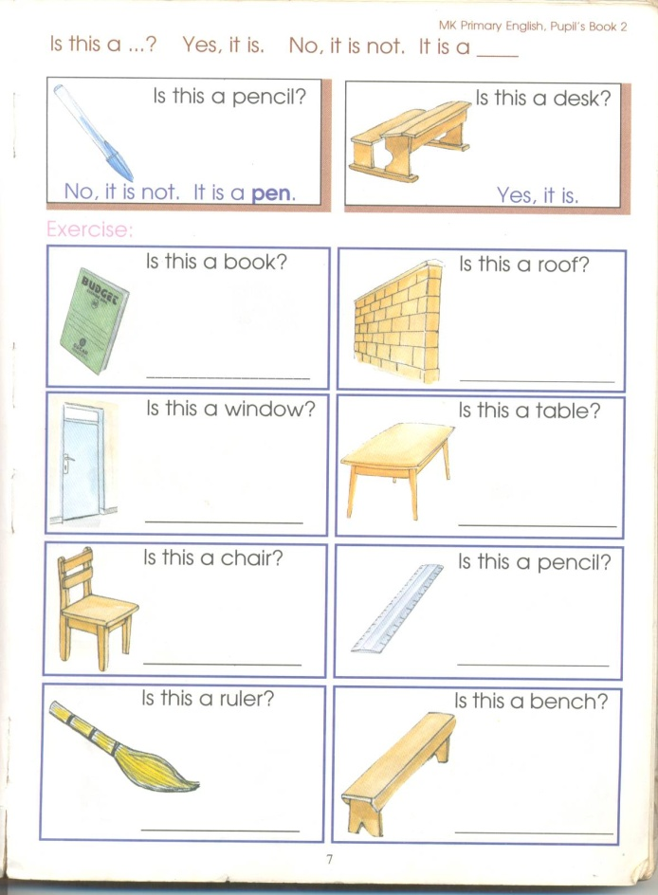

-

Activities

* Identifying the pictures.
* Recognizing the pictures.
* Drawing good pictures.
* Subtracting the pictures
* Answering the questions.

Period 3

Content:

-



-

Activities

* Identifying the pictures
* Recognizing the pictures
* Drawing the pictures
* Answering the questions
* Subtracting the pictures

Period 4

Content:

Subtraction of numbers

2 - 1 = __ 2 – 2 = ___ 2 – 0 = __

Activities

* Identifying the numbers
* Recognizing the numbers
* Writing the numbers
* Subtracting the numbers
* Answering the question

Period 5

Content

Subtracting the numbers.

5 - 2 = ___ 0 - 0 = ___ 4 - 3 = ___ 6 - 3 = __

Activities

* Identifying the numbers
* Recognizing the numbers
* Writing the numbers.
* Subtracting the numbers.
* Answering the questions.